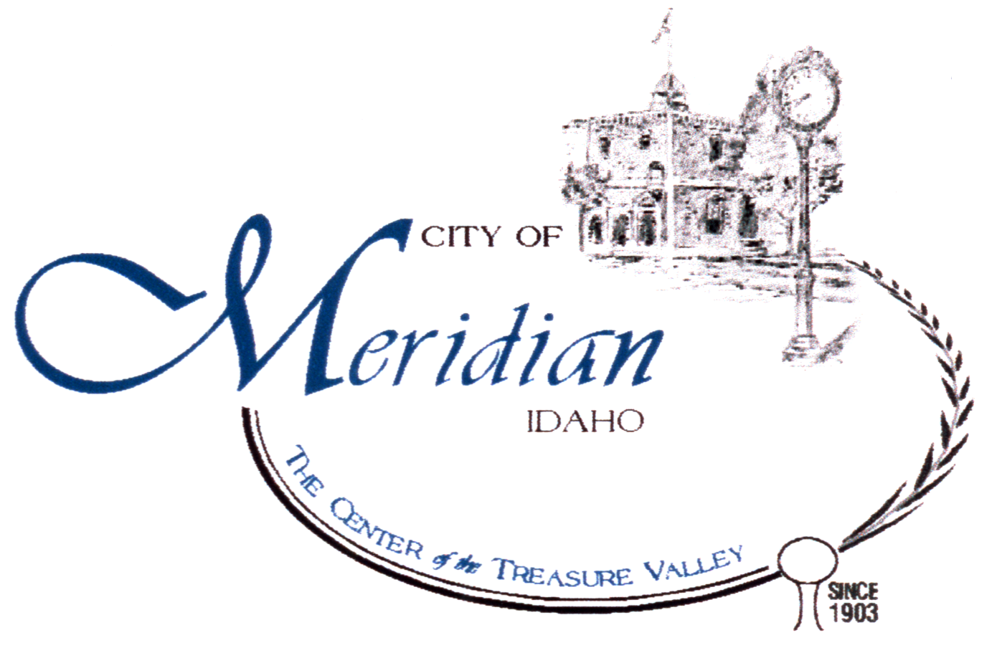

Meridian Water Dept.

2235 N.W. 8TH STREET

MERIDIAN, ID 83642
(208) 888-5242
(208) 884-1159 FAX
www.meridiancity.org

PWS # 4010097

Annual Water Quality Report
2005

We want to inform you about the quality of the water and the services that we deliver to you every day. We are committed to providing a safe and dependable supply of drinking water to approximately 22,000 connections serving about 66,000 customers. Our water is pumped from deep in the Boise Aquifer. We currently operate twenty supply wells located throughout the City.

We are required to report annually on the water quality from the previous year. We routinely monitor for contaminants in your drinking water according to Federal and State laws. Testing frequencies range from monthly to once every nine years, depending on the contaminant.

Drinking water, including bottled water, may reasonably be expected to contain at least small amounts of some contaminants. The presence of contaminants does not necessarily indicate that water poses a health risk. More information about contaminants and potential health effects can be obtained by calling the Environmental Protection Agency’s Safe Drinking Water Hotline at 1-800-426-4791 or http://www.epa.gov/safewater/hotline.

The following definitions may help you better understand the terms and abbreviations in the table on the following pages.

Parts per million (ppm) or Milligrams per liter (mg/l) - one part per million corresponds to a single penny in $10,000.

Parts per billion (ppb) or Micrograms per liter (ug/l) - one part per billion corresponds to a single penny in $10,000,000.

Maximum Contaminant Level Goal - The “Goal”(MCLG) is the level of a contaminant in drinking water below which there is no known or expected risk to health. MCLGs allow for a margin of safety.

Action Level- The concentration of a contaminant, which, if exceeded, triggers treatment, or other requirements which a water system must follow.

Maximum Contaminant Level - The “Maximum Allowed” (MCL) is the highest level of a contaminant allowed in drinking water. MCLs are set as close to the MCLGs as feasible using the best available treatment technology. MCL’s are set at very stringent levels. A person drinking 2 liters, about ½ U.S. gallons, of water every day for a lifetime at the MCL level would have a one-in-a-million chance of having the described health effect. Some people are more vulnerable to certain contaminants than others in the general population. Those persons who are immune-compromised, some elderly persons and infants are most susceptible. These people should seek advice from their health care providers about the water they drink.

We are proud of this table, which shows that your drinking water meets or exceeds all Federal and State requirements. We have learned through our monitoring and testing that some contaminants are present. However, your water IS SAFE at the levels detected. Remember that the mere presence of a contaminant does not necessarily indicate that the water poses a health risk. More information about contaminants and their potential health effects may be obtained by calling the Environmental Protection Agency’s Safe Drinking Water Hotline at 1-800-426-4791 or http://www.epa.gov/safewater/hotline/.

If you are not on Meridian's City Water System, the amount of contaminants in your water will differ from those listed on the preceding pages. If you have a private well, you should consider testing your water for certain contaminants, especially bacterial contaminants, on a regular basis.

In order to ensure that tap water is safe to drink, EPA prescribes regulations which limit the amount of certain contaminants in water provided by public water systems. Food and Drug Administration (FDA) regulations establish limits for contaminants in bottled water which must provide the same protection for public health.

Some people may be more vulnerable to contaminants in drinking water than the general population. Immuno-compromised persons such as persons with cancer undergoing chemotherapy, persons who have undergone organ transplants, people with HIV/AIDS or other immune system disorders, some elderly, and infants can be particularly at risk from infections. These people should seek advice about drinking water from their health care providers. EPA/CDC guidelines on appropriate means to lessen the risk of infection by cryptosporidium and other microbiological contaminants are available from the Safe Drinking Water Hotline at 1-800-426-4791 or http://www.epa.gov/safewater/hotline/.

Contaminants that may be present in source water before we treat it include:
- Microbial contaminants, such as viruses and bacteria, which may come from sewage treatment plants, septic systems, agricultural livestock operations, and wildlife.
- Inorganic Contaminants, such as salt and metals, which can be naturally-occurring or result from urban storm water runoff, industrial, or domestic water discharges, oil and gas production, mining, or farming.
- Pesticides and herbicides, which may come from a variety of sources such as agriculture, urban storm water runoff, and residential uses.
- Organic chemical contaminants, including synthetic and volatile organic chemicals, which are by-products of industrial processes and petroleum production, and can also come from gas stations, urban storm water runoff, and septic systems.
- Radioactive contaminants, which can be naturally-occurring or be the result of oil and
gas production and mining activities.

The sources of drinking water (both tap water and bottled water) include rivers, lakes, streams, ponds, reservoirs, springs, and wells. As water travels over the surface of the land or through the ground, it dissolves naturally-occurring minerals and, in some cases, radioactive material, and can pick up substances resulting from the presence of animals or from human activity.

Please help us to protect and conserve this vital resource. A dependable supply of clean, high-quality water is essential to our community, our way of life, and our children’s future. We want to keep you informed about your water utility. If you have questions about this report or concerns about your water utility, please contact Rick Clinton at (208) 888-5242 or visit our website at www/meridiancity.org. The City of Meridian City Council generally has regularly scheduled meetings every Tuesday.

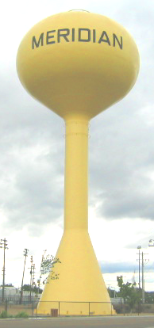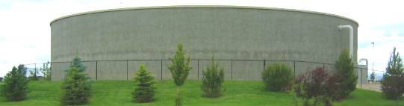

What we are doing to maintain and improve the quality of water in Meridian:

- We are taking steps to meet the standards for public consumption of water. Newly required monitoring under USEPA’s radiological rule requires monitoring for uranium for all ground water wells. Dissolved uranium is common in ground water supplied in the area and can only pose a heath risk if levels exceed the MCL for a period of many years. * Well 23 has been in operation a relatively short period of time. Although this monitoring has just commenced, results are based on a running average of four quarterly samples in a given year. Well 23 could have possibly exceeded the limit established by EPA but was shut down to evaluate treatment solutions before a violation occurs. The City is continuing to monitor uranium levels and is diligently working to keep the water safe.

- We are proud to be one of the first systems in Idaho to use poly vinyl chloride (PVC) well casings. PVC casing significantly reduces water quality concerns associated with the corrosion of steel casing.

- We have one of the best cross connection control programs in Idaho. The risk of contamination from sources outside our water system is reduced as we implement cross connection control.

- We chlorinate the water, which kills harmful organisms and reduces the undesirable taste and odor sometimes caused by natural occurring minerals.

- Water mains are flushed annually. Flushing clears out the buildup of naturally-occurring sediments within the system that can cause discoloration and taste and odor problems. We are continuing to add permanent flush lines that will expand our wintertime flushing capability.

- Multiple aquifers sampling from test wells enables us to target the aquifer that provides the finest quality of water when we construct new wells.

- We have implemented security improvements to insure that your water remains safe.

- We collected over 700 water samples for lab analysis of various contaminants in 2005.

Meridian Water Department Conservation Tips

- Water your lawn early in the morning or at night to avoid excess evaporation. Do not over-water your lawn.
- Fully load the dishwasher and clothes washer before running.
- Defrost frozen food in the refrigerator or in the microwave instead of running hot water over the food.
- When washing dishes by hand, do not let the water run.
- Use a broom, rather than a hose, to clean sidewalks and driveways.
- If you have a swimming pool, use a cover. You will cut the loss of water due to evaporation by 90 percent.
- Repair dripping faucets and leaky toilets. Dripping faucets can waste up to 2,000 gallons of water each year in the average home. Leaky toilets can waste as much as 200 gallons per day.
- Do not leave the sink running while you brush your teeth.

Drinking water is one of our most important and valuable natural resources. We urge you to conserve water, and also your money, by using it wisely.

Source: AWWA

